H.T No
Regulations:
A20

Sreenidhi Institute of Science and Technology
(An Autonomous Institution)
Code No: 8AC42 Date: 21-Sept-2023 (FN)
B.Tech I-Year I- Semester External Examination, September-2023 (Supplementary)
ELECTRICAL CIRCUITS AND NETWORK ANALYSIS (ECM)

Time: 3 Hours Max.Marks:70

Note: a) No additional answer sheets will be provided.
b) All sub-parts of a question must be answered at one place only, otherwise it will not be valued.
c) Missing data can be assumed suitably.
Bloom's Cognitive Levels of Learning (BCLL)

Remember | L1 | Apply | L3 | Evaluate | L5
Understand | L2 | Analyze | L4 | Create | L6

Part - A Max.Marks:20

Answer all QUESTIONS.

 |  | BCLL | CO(s) | Marks
1 | State Ohm’s Law. | L1 | CO1 | [2M]
2 | Determine the RMS value of an AC Sinusoidal Waveform. | L2 | CO2 | [2M]
3 | Distinguish between electrical and magnetic circuits. | L2 | CO3 | [2M]
4 | State Maximum Power transfer Theorem. | L2 | CO4 | [2M]
5 | Write the relation between the Z and Y parameters of a Two-port network. | L1 | CO5 | [2M]
6 | What is meant by Transient Analysis. | L1 | CO6 | [2M]
7 | What is meant by Quality factor. What are the parameters on which it depends. | L2 | CO2 | [2M]
8 | Explain about dot convention. | L2 | CO3 | [2M]
9 | Express the transmission parameters in the form of a Two Port Network. | L1 | CO5 | [2M]
10 | Explain about a Super Node. | L1 | CO1 | [2M]

Part – B Max.Marks:50
ANSWER ANY FIVE QUESTIONS. EACH QUESTION CARRIES 10 MARKS.

 |  |  | BCLL | CO(s) | Marks
11. | a) | Find i_{o} in the circuit using source transformation.  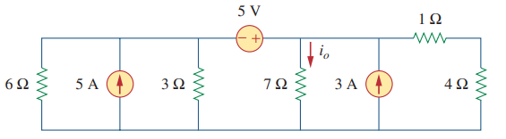 | L3 | CO1 | [5M]
 | b) | Obtain the node voltages in the circuit.  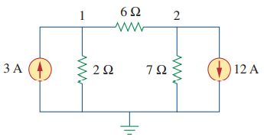 | L3 | CO1 | [5M]
12. | a) | A coil of resistance 40 Ω and inductance 0·75 H forms part of series circuit for which the resonant frequency is 55 Hz. If the supply is 250 V, 50 Hz, find (i) line current, (ii) power factor of total circuit and coil, (iii) voltage across the coil. | L3 | CO2 | [5M]
 | b) | A series RLC circuit with R=10 Ohm, L=0.1 H and C=50 µF has an applied voltage V=50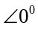 with a variable frequency .Find the resonant frequency, the value of frequency at which maximum voltage occurs across the inductor and the value of frequency at which maximum voltage occurs across the capacitor. | L4 | CO2 | [5M]
13. | a) | Two similar coils connected in series gave a total inductance of 600 mH and when one of the coil is reversed, the total inductance is 300 mH. Determine the mutual inductance between the coils and coefficient of coupling. | L3 | CO3 | [5M]
 | b) | Illustrate the dot convention of coupled circuits. | L2 | CO3 | [5M]
14. | a) | Find the Norton equivalent circuit for the circuit shown in the figure at terminals a-b.  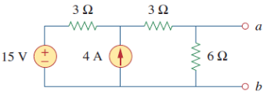 | L3 | CO4 | [5M]
 | b) | For the circuit shown below, use the superposition theorem to find the current i  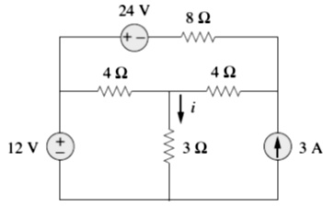 | L3 | CO4 | [5M]
15. | a) | The Z-parameters of a two-port are Z₁₁ =10Ω, Z₂₂=20Ω, Z₂₁=Z₁₂=5Ω (a) Find the ABCD parameters. (b) Find the equivalent T-network. | L3 | CO5 | [5M]
 | b) | Express the ABCD parameters of a Two port network in terms of Y parameters. | L2 | CO5 | [5M]
16. | a) | A series R-L circuit has R = 25 Ω and L = 5H. A DC voltage of 100 V is applied at t = 0. Find: (a) The equations for charging current, voltage across R and L. (b) The current in the circuit 0.5 sec later. (c) The time at which the drop across R and L are same. | L3 | CO6 | [5M]
 | b) | A series R-C circuit with R=10 ohms and C= 2F has a sinusoidal voltage source 200 sin(500t+Փ) applied at time when Փ=0. Find the expression for current. | L3 | CO6 | [5M]
17. | a) | Find an equivalent resistance between A and B for the circuit shown.  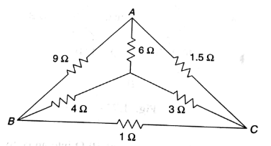 | L2 | CO1 | [4M]
 | b) | The impedances of a parallel circuit are Z1 = (6 + j8) ohms and Z2 = (8 - j6) ohms. If the applied voltage is 120V, find (i) current and power factor of each branch (ii) overall current and power factor of the combination. | L3 | CO2 | [3M]
 | c) | A ring shaped electromagnet has an air gap of 6 mm and 20 cm² in area, the mean length of the core being 50 cm and its cross section is 10 cm². Calculate the ampere-turns required to produce a flux density of 0.5 Wb/m² in the gap. Assume the permeability of iron is 1800. | L3 | CO3 | [3M]
18. | a) | Find Thevenin’s Equivalent circuit at terminals a-b.  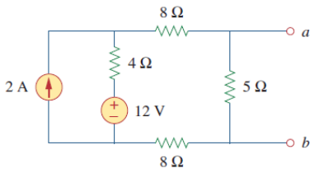 | L3 | CO4 | [4M]
 | b) | Derive the symmetry for ABCD parameters. | L5 | CO5 | [3M]
 | c) | Derive the expression for i(t) and voltage across capacitor V_{c}(t) for series RC circuit with D.C voltage applied to it at t=0 | L5 | CO6 | [3M]
-- 00 -- 00 –

